|  |  |
| --- | --- |
| USAID Logo | USAID GLOBAL HEALTH SUPPLY CHAIN PROGRAM  Procurement and Supply Management |

|  |
| --- |
| Facility Inventory Turnover Analysis  **User Guide**  August 2024 |

The USAID Global Health Supply Chain Program-Procurement and Supply Management (GHSC-PSM) project is funded under USAID Contract No. AID-OAA-I-15-0004. GHSC-PSM connects technical solutions and proven commercial processes to promote efficient and cost-effective health supply chains worldwide. Our goal is to ensure uninterrupted supplies of health commodities to save lives and create a healthier future for all. The project purchases and delivers health commodities, offers comprehensive technical assistance to strengthen national supply chain systems, and provides global supply chain leadership.

GHSC-PSM is implemented by Chemonics International, in collaboration with Arbola Inc., Axios International Inc., IDA Foundation, IBM, IntraHealth International, Kuehne + Nagel Inc., McKinsey & Company, Panagora Group, Population Services International, SGS Nederland B.V., and University Research Co., LLC. To learn more, visit [ghsupplychain.org](http://www.ghsupplychain.org/)

DISCLAIMER:  
The views expressed in this publication do not necessarily reflect the views of the U.S. Agency for International Development or the U.S. government.

**Contents**

Step 1: User System Setup 4

Step2: Running the Tool 5

Step 3: Open the Final Report………………………………………………………………………………………………………………….9

Step 4: Analyzing the Final Report……………………………………………………………………………………………………………9

National Summary Page……………………………………………………………………………………………………………10

Facility Analysis Page……………………………………………………………………………………………………………….12

**Facility Inventory Turnover Analysis User Guide**

# **Note:**

* **User System setup** and **step 1.6** needs to be done only the first time a user downloads the code.
* If python and the packages to run the tool are already installed, start from step 1.1.

## Step 1: User System Setup

### Install Python

Install the latest version of python from this webpage <https://www.python.org/downloads/> that is appropriate for your computer. Go through the installation prompts on your computer as directed. Alternatively, reach out to your IT department for help installing python.

### Install Python Packages

In the folder that contains the tool you will see a document called **requirements.txt**. This document helps to quickly install all the libraries needed to run this program.

To do this, open the **command prompt** on your computer by searching for it in your desktop search bar and navigate to the to3-inventory-analysis folder

1.1 Copy the path to the folder – Right click on the folder name (highlighted below) and select Copy address.

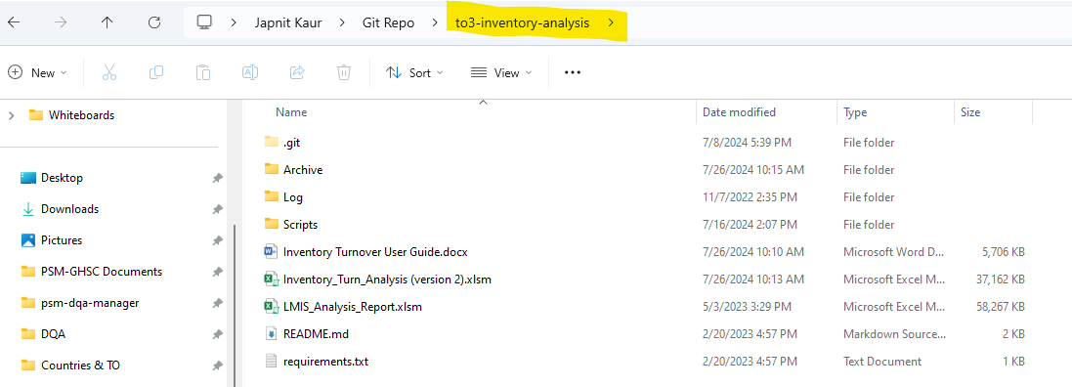

* 1. To navigate to the program folder in the command prompt enter the following code after the >

cd *paste*/*path/to/the/to3-inventory-analysis/folder*

* 1. Press Enter. The folder path should now appear before the >

* 1. To activate virtual environment: *(optional step but recommended to avoid dependency conflicts)*

cd IT_env/Scripts press enter then type activate and enter. #On Windows

source IT_env/bin/activate # On Linux or macOS

(IT_env) before your path indicates you are now inside virtual environment

Note: To exit the virtual environment enter deactivate

* 1. Type the following to go back to original folder: cd../..

1.6 Enter the following text into the command prompt to install dependencies:

pip install -r requirements.txt

* 1. You will see text running in the command prompt, which is installing each package. Once all libraries are installed you should return to showing the line with your current folder followed by >.

Package installation is now complete.

## Step 2: Running the tool

Follow the steps below to run the tool

1. Once the setup is done, navigate to the “Scripts” folder by typing the command *cd Scripts* in the command prompt

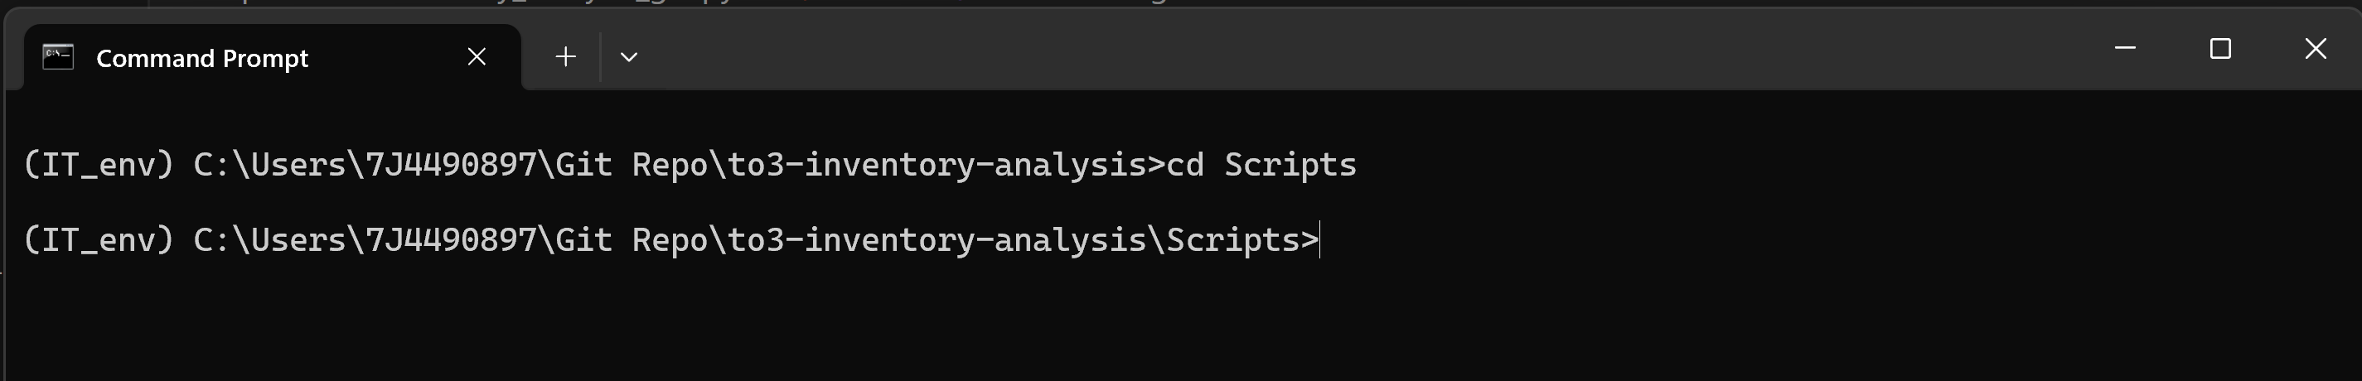

1. Next run the tool with the following command: *python inventory_analysis_gui.py*

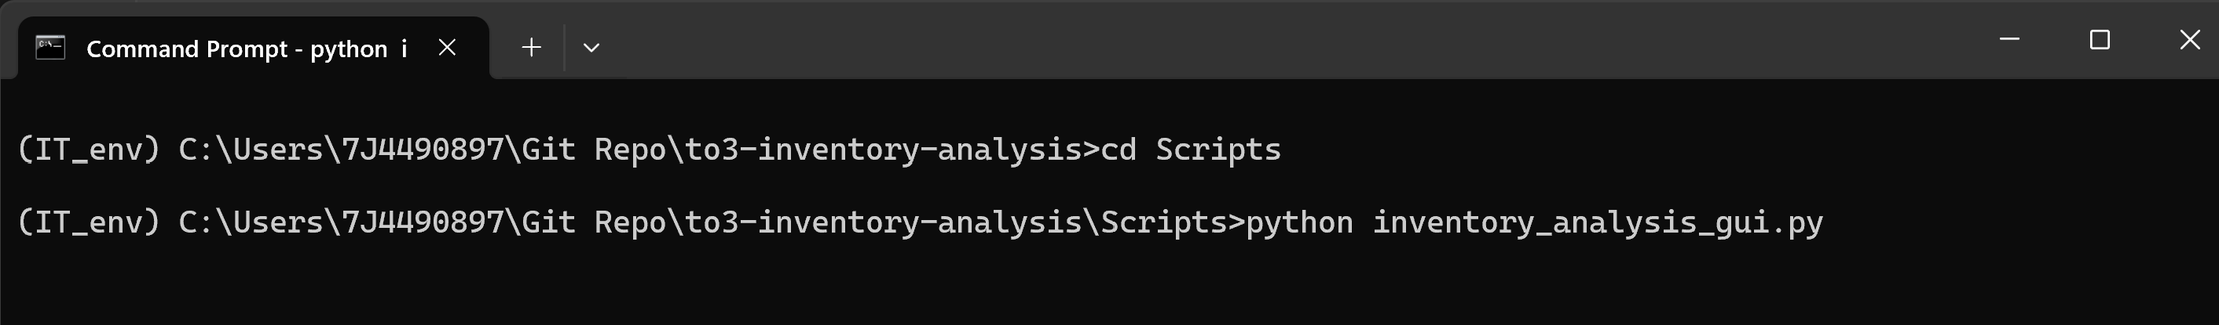

1. Press Enter and a graphical user interface will pop up with a prompt to browse a file.

1. Click the Browse Files button to navigate to a stock file that contains at least one year of date, region, consumption and stock on hand fields for facility and product-level data. This file usually comes out of an eLMIS system and needs to be either an excel or a csv file. The opened file name will be displayed at the top in blue. Here is an example data:

Note: Region column is required and can be district/state/province which helps in uniquely identifying a product-facility row.

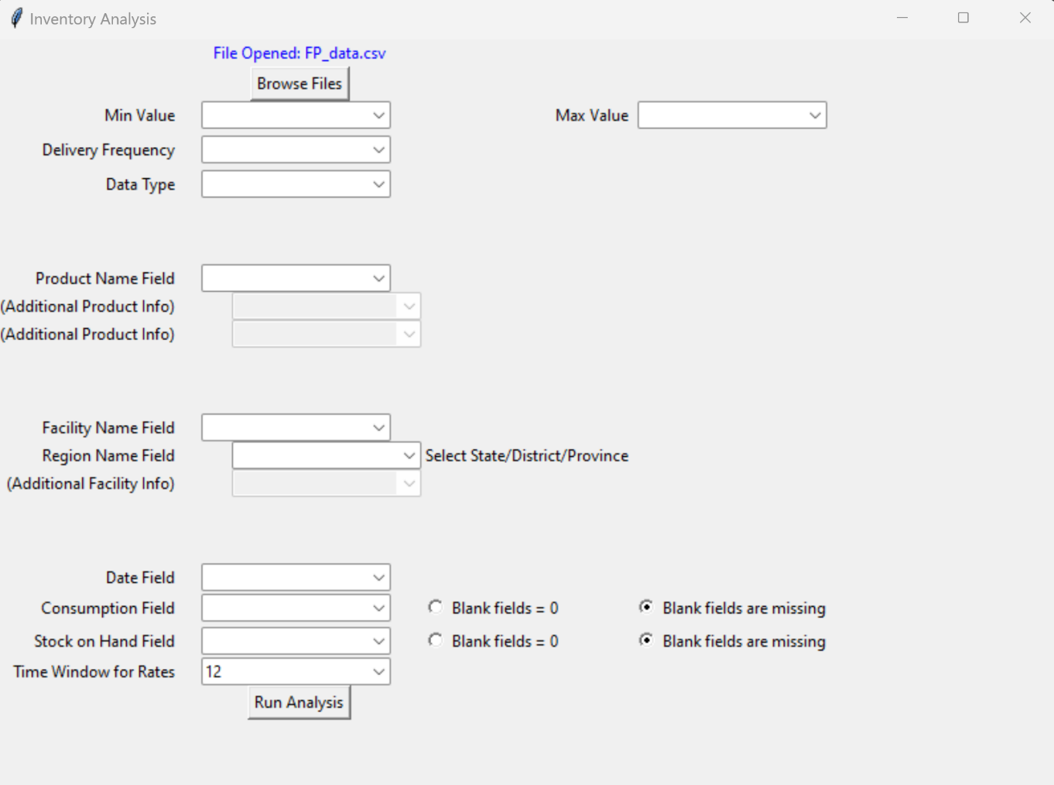

1. Next select values from the drop downs for each field.

* **Min Value**: Select a min months of stock value according to the country’s inventory control policies for health facilities
* **Max Value**: Select a max months of stock value according to the country's inventory control policies for health facilities
* **Delivery Frequency**: Select one from Monthly, bimonthly or Quarterly Delivery frequency according to country’s policies for delivery to health facilities

Note: The min, max and delivery frequency fields help calculate an ideal Inventory Turn range (called Planned Inventory Turnover in the final dashboard), where all products in a facility are expected to fall.

* **Data Type**: Select transactional if the selected input file contains multiple entries for a single month. If the stock data contains one entry per month for a facility/product combination, select cumulative.
* **Product Field**: Select the field name from the dropdown menu that corresponds to product names column in the input file
* **Facility Name Field**: Select the field name from the dropdown menu that corresponds to facility name column in the input file
* **Region Name Field**: Select the field name from the dropdown menu that corresponds to either State, District or Province or any field that helps narrow down on a geographical grouping of facilities.
* **Date Field**:Select the field name from the dropdown menu that corresponds to date column in the input file
* **Consumption Field**: Select the field name from the dropdown menu that corresponds to consumption data column in the input file
* **Stock on Hand Field**: Select the field name from the dropdown menu that corresponds to stock on hand or closing balance data column in the input file
* **Time Window for Rates**: Select an integer value for calculations of inventory turns over a rolling window. By default, 12 is selected for a rolling window of one year. If the products you are assessing have seasonality, you may want to adjust the window to be approximately the length of the seasons.
* **Blank Fields (radio buttons):** Make selections to handle missing SOH and consumption values. By default, Blank fields are missing is selected.

Once all selections are made, click “Run Analysis” Button. The image below shows an example of what this form may look like after it has been filled out.

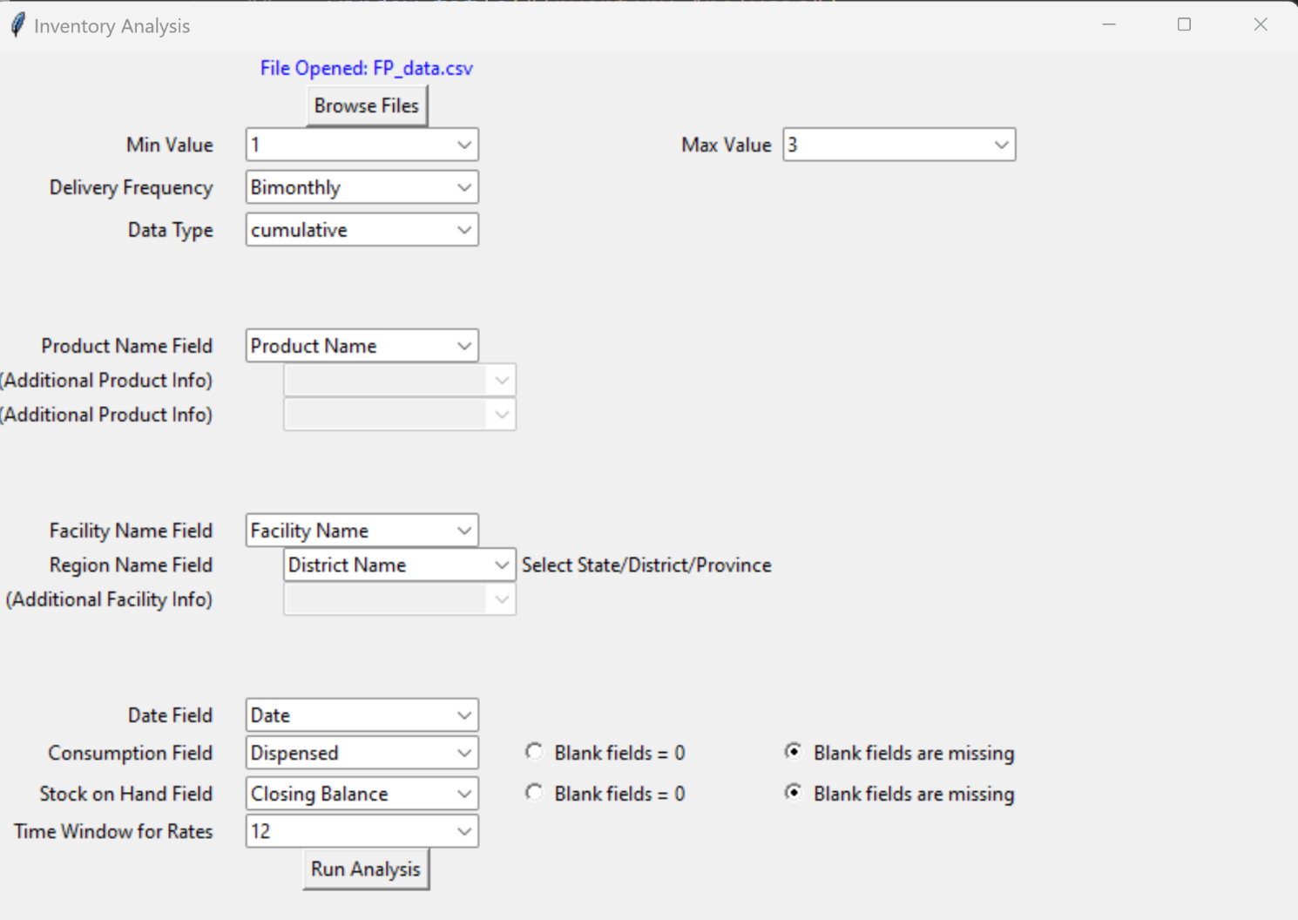

## Step 3: Open the Final Report

Once the tool is done running, click the “open report in excel” button to open the final dashboard.

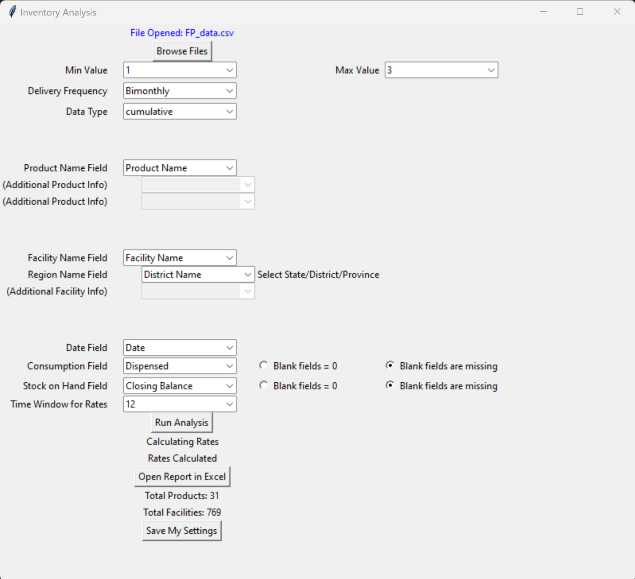

## Step 4: Analyzing the Final Report

Once the final report opens, click the “Enable Content” button in the yellow warning ribbon. This will enable all the macros and features running in the background in the excel workbook.

Next navigate to Data option on the ribbon at the top and click “Refresh all” to refresh the tool and pull the output files from the most recent run. This may take a few minutes.

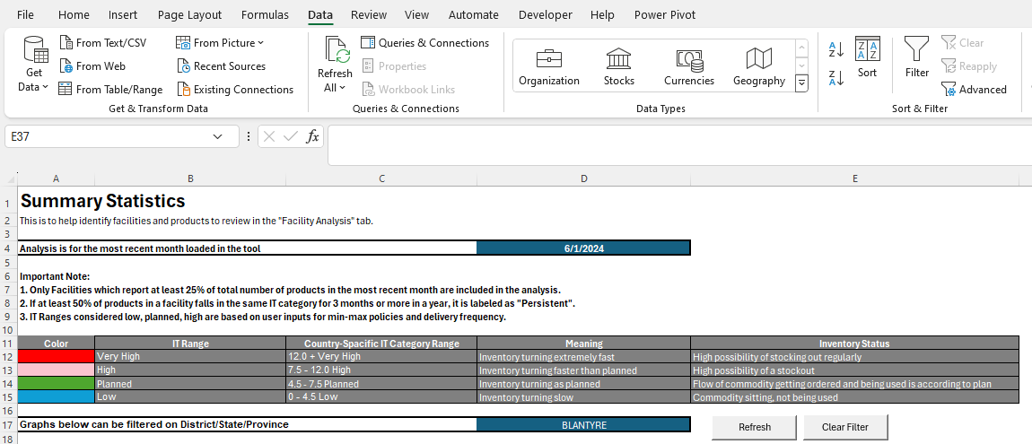

Troubleshoot Tips: If an error pop up saying something could not be refreshed, open queries and connections next to refresh all, individually refresh each query by right clicking and selecting refresh

#### National Summary Page

User can now analyze the “National Summary” tab for the most recent month in the input stock file. The aim is to identify facilities in the very high, high or low Inventory Turnover range category on this page and do an in-depth analysis on the next page for each of these identified facilities. If you already have a particular facility in mind that you are trying to get more information about, you can skip this page and go to Facility Analysis.

The page displays the month of analysis at the top (based on the final month of data available in the file uploaded in Step 2) followed by a description of each Inventory turn category along with the color it used for each category in the charts below.

The country-specific Inventory Turnover Category Range is calculated based on the min, max and delivery frequency provided by the user when setting up the tool in Step 2. The colors against each category denote the color used in the charts below for each. User can use the region (District/state/province) filter (highlighted in a blue box) to filter for one particular value.

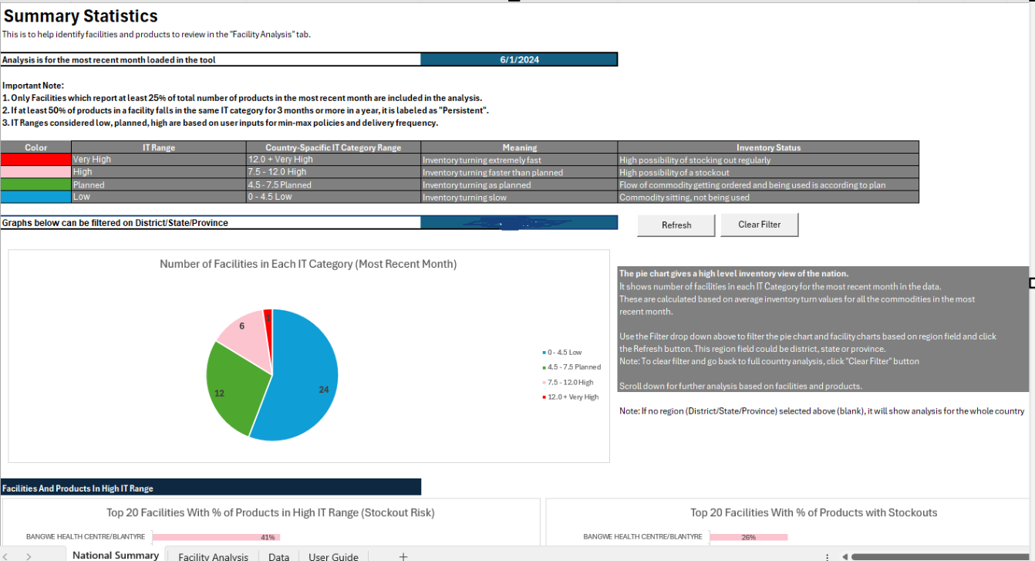

To filter on region:

* Select a value from the drop down and click “Refresh” button
* Use “Clear Filter” button to go back to country-wide analysis

Scroll down to narrow down on facilities not falling in the planned Inventory Turnover Range with the help of bar charts. The gray boxes throughout the screen help define or describe different elements of the analysis and tool.

#### Facility Analysis Page

##### Step 1

Once the user has identified facilities from the National Summary page they can do further analysis on the Facility Analysis page. On this page the user can find a facility by first selecting a region and then selecting the facility from a filtered drop-down list. The list can be filtered further if you start typing in the name.

They can then see number of products in the selected facility falling in the different Inventory Turnover Ranges over a year through stacked column charts. A change in pattern could indicate reduced capacity at the facility level; for example, maybe the staff who received detailed eLMIS training recently left and the new staff was not as thoroughly changed. In the example below, the facility’s stock management is actually improving over time as the green “planned” bar is getting bigger.

Next the user can filter for one month in a year (typically, the most recent month) and see a list of products with their Inventory Turnover category in a bar chart. This helps user pick problematic products to analyze in the next step.

##### Step 2

In the next step on the “Facility Analysis” page, user can select a product from the drop-down list and through Inventory Turnover, Consumption and MOS charts over a year, can visualize a potential cause for this product not following a planned Inventory Turnover trend. The descriptions in grey boxes on the side help the user interpret these charts.

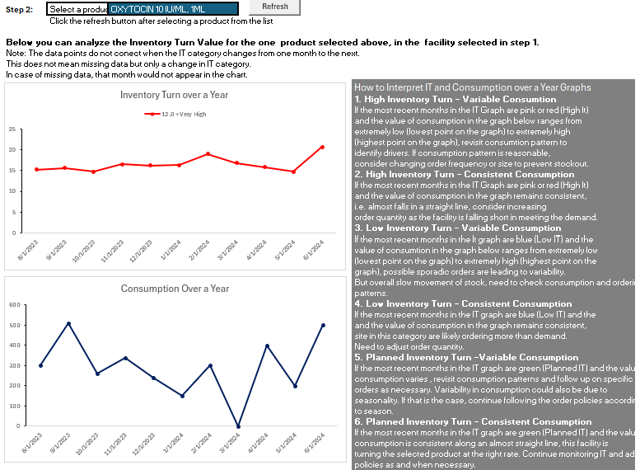

The Raw Data tab can also be used to validate these charts and get more insight through additional columns such as, AMC and MOS, by filtering on the facility, region and product that you are investigating.